# OVERVIEW OF CONFLICT

Houthi rebels have been attacking ships in the Red Sea since November, disrupting global trade on a key waterway linking Asia, the Middle East, and Europe. The Suez Canal, one of the world's most important shipping routes, is located in the Red Sea. The attacks began with ships in direct contact with Israel, but eventually, all ships were targeted. In October 2023, Houthi rebels attacked Israel with anti-ship ballistics and weapons from Iran. As a result, a coalition headed by the US was established to defend Red Sea shipping against Houthi attacks. The battle between the Houthis and the USA-UK led task force is now spreading. The Red Sea is a bridge connecting Africa, Asia, and Europe, and it is estimated that 10-15% of the world's maritime trade takes place through it. Bab El Mandepe, a small geographic chokepoint on the Red Sea, has a major impact on world politics. The Houthis have been attacking ships in this ancient waterway that are connected to Israel, the United States, or the United Kingdom to press for an end to Israel's war on Gaza.

Houthi rebels in Yemen are targeting commercial and naval ships sailing through the Red Sea that are connected to Israel, the United States, or the United Kingdom to force an end to Israel's war on Gaza. On November 19, 2023, the Houthis captured the crew of a commercial ship and have been using drones, missiles, and small boats to attack ships. British-owned ships have been hit, including the Galaxy Leader that was attacked on its way from Turkey to India, and the Rubimar, which was damaged as it sailed through the Bab al-Mandeb Strait. Since the start of the airstrike, nine ships have been attacked, five of which have ties to the United States or the United Kingdom. They targeted the container ship that was making its way from Singapore to Egypt because it was headed for "occupied Palestine."

An anti-ship ballistic drone target hit the Norwegian tanker carrying biodiesel from Saudi Arabia to reunion it was hit. The US and UK have initiated military operations in Yemen, targeting Houthi rebels who have been attacking trade routes in the Red Sea. The Houthis have responded by threatening to attack US and British assets. The operation has involved more than 150 weapons and has targeted underground weapons storage facilities, missile systems, air defense systems, and radars in nearly 30 locations across Yemen. The strikes have been conducted by the US-UK-led OPG, with 16 locations targeted by Tomahawk cruise missiles. The capital, Sana'a, and the Houthi Red Sea port stronghold of Hudaydah have been hit hard.

# ROOT CAUSES

The Houthis group is attacking ships on the world trade route due to their support for the Amas organization in the Israel-Palestine conflict. Additionally, they aim to establish legitimate authority and government in Yemen, which prompts them to attack major superpower ships. The US and the UK are involved in the conflict to safeguard the world trade, protect their economic interests, and show support for Israel.

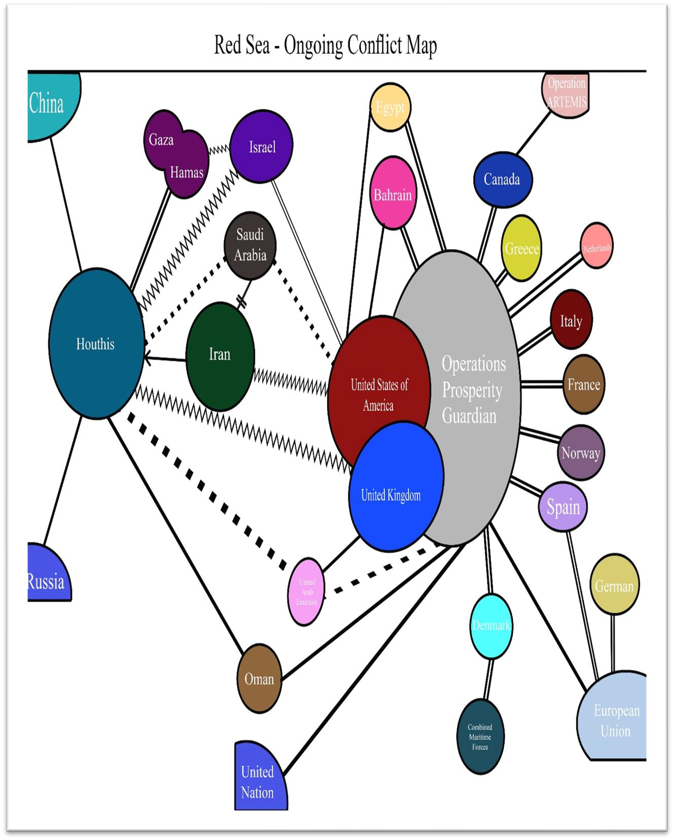

# PARTIES

•Houthis-The main rebel group that is launching attacks on ships in the Red Sea Bab al-Bandal.

•USA, UK led task force Another significant combatant group that is assaulting the Houthis and defending the Red Sea is called Operation prosperity Guardian-Operation prosperity guardian -A multinational operation was organized by the US Defense Secretary as part of Operation Prosperity Guardian to guarantee safe transportation across the region. Due to the attacks, shipping companies have redirected their ships away from the Red Sea and Gulf of Aden, resulting in longer travel times, higher freight rates, and increased insurance costs due to Houthi attacks. To address this issue, the US has launched Operation Prosperity Guardian, a multinational mission to ensure safe passage through the region. The mission aims to protect the vital trade route and maintain economic prosperity,

Bahrain, Denmark, and Canada are members of the OPG alliance and provide support to the US Navy. The French Alliance has troops in Djibouti and a naval station in the UAE. Egypt supports the USA militarily. Norway sends staff officers to the CMF headquarters. Italy and Greece send naval ships to the Red Sea. Netherlands sends staff officers to CMF's headquarters. Spain only participates in EU-coordinated actions. Iran and Israel are involved in the conflict in Gaza. UAE silently supports OPG and maintains communication with the Houthis. Saudi Arabia weakly supports the US and has a strained relationship with the Houthis. The European Union fully supports OPG. Germany is part of an EU alliance supporting OGP. Russia defends the Houthis and criticizes US attacks. China also supports the Houthis. Turkey claims not to bomb the Houthis and criticizes US actions. Oman acts as a mediator. The United Nations works to halt attacks and supports OPG as a peacekeeper.

# MOTIVES

The United States plays a critical role in the Red Sea conflict through Operation Prosperity Guardian, a multinational coalition it leads. America's intervention is driven by a mix of economic and security concerns. The Red Sea is a vital trade route for the world, and Houthi attacks threaten this economic lifeline. The US aims to ensure the free flow of goods and maintain global economic stability. Additionally, the US champions freedom of navigation on international waters, which Houthi attacks violate. By deterring these attacks, the US upholds international law. Furthermore, the US has security alliances with regional countries threatened by the Houthis. America's intervention safeguards these allies and promotes regional stability.

UK The UK has a vested interest in the Red Sea's stability due to its importance as a trade route for essential goods and oil. Houthi attacks on ships threaten this economic lifeline, prompting the UK to take action alongside the US. The UK aims to prevent such a scenario by deterring Houthi attacks and promoting regional stability

The Houthi movement, also known as Ansar Allah, has a slogan highlighting their anti-Western and anti-Israel views: "God is the greatest, Death to America, Death to Israel, A Curse Upon the Jews, Victory to Islam."

This reflects their opposition to the US-backed Saudi coalition fighting them in Yemen's civil war. They see the US as Israel's protector.

The Houthis aim for international recognition as Yemen's rulers. They attack ships in the Red Sea to raise their profile and disrupt trade, hoping to pressure both Saudi Arabia and Israel.

The Red Sea is a new area of conflict between the US and Iran. Iran isn't directly involved, but it supports the Houthi rebels in Yemen. Iran's goals are to influence the region and challenge US dominance. The US sees Iran as a threat due to its nuclear program, support for militias, and involvement in regional issues. Iran uses the Houthis to weaken US interests and assert its own power. It provides the Houthis with weapons and intelligence, and aims to frighten other countries in the region.

Iran is backing Yemen's Houthis, escalating tensions with the US in the Red Sea. Iran aims for regional influence and opposes US dominance. Its nuclear program and support for militias are seen as threats by the US. Iran also scares countries like Saudi Arabia and disrupts US interests. To counter this, Bahrain joins the US-led alliance. Saudi Arabia seeks diplomacy despite the conflict's harm. The UAE prioritizes business and indirectly supports the US/UK. In their operation, US and UK get help from other countries to fight the well-strategized Houthis.

# POWER DYNAMICS

Analyzing the Red Sea conflict from a power point of view reveals that the task force led by the US and the UK has more power.

Warships from the US and UK have been deployed to the area to patrol critical shipping lanes and deter Houthi attacks. Accurate intelligence on Houthi activity and potential threats is shared between the US and UK, allowing for preemptive reactions. The UK's Royal Navy, represented by the HMS Diamond, protects merchant ships and ensures freedom of navigation in the Red Sea region. Its advanced air defense system with Sea Viper missiles directly addresses the Houthi threat. The presence of the Royal Navy and its advanced technologies demonstrate the UK's commitment to secure maritime environments. Bahrain, Egypt, Denmark, and Canada also provide military and naval support to the US and UK-led task force, further enhancing their power in the conflict. The Houthi rebels have targeted large ships using their own weapons, including drones, short-range missiles, and shoulder-fired missile systems, received from Iran.

Iran has been a continuous supplier of weapons to the rebels throughout the Yemeni civil war. The Operation PROSPERITY Guardian is a USA and UK-led task force receiving voluntary and indirect support from various countries. With direct and indirect contributions were made by many countries for the conflict. Despite the multitude of nations supporting the task force, the surprising power of the Houthi rebels, aided by Iran and organizations such as Hezbollah, is noteworthy.

Examining the strength of nations involved, the USA and Israel possess the capability to attack the Houthis due to their military might. Although initially weaker than the Houthis, the situation changes when they receive assistance from the United States. Notably, Russia and China, world powers, support and stand with the Houthis, further bolstering their strength. Saudi Arabia, engaged in peace talks with the Houthis, remains silent in the conflict to protect its own security interests and business ventures. Similarly, the United Arab Emirates maintains an informal relationship and supports the USA and UK, making them a significant player in the conflict.

Also, comparing other countries, US has more strength in Israel, it is possible for them to attack the Houthis in this conflict. Recently they have continued to attack, they have troops and weapons in this conflict and their strength is less than the Houthis, but this situation has changed since they receive the help of the United States. On the other hand, Russia and China, as global powers, are supporting and backing the Houthis, which strengthens their position. Saudi Arabia has been engaged in peace talks with the Houthis after Yemen civil war but currently remains silent, prioritizing its own security and business interests. The UAE's power lies in its informal relationship with the US and the UK, making it influential in the conflict. In contrast, the EU fully supports Operation Prosperity Guardian and is backed by Germany's navy. So, here Middle Eastern country UAE is somewhat powerful in this conflict and has power over other big countries like Canada and Denmark., more than any other country in the alliance, because they provide naval assistance to the United States in many ways. In addition to this, the conflict also involves the power of external organizations such as the United Nations, and the European Union, combined maritime force, operation ARTEMIS.

Houthis, backed by Iran, attacked US ships with missiles and drones. This highlights their growing precision and targeting of large vessels. Since November, they've launched frequent attacks in the Red Sea, raising concerns for commercial ships due to the Houthis' use of small, agile boats potentially carrying explosives. The Houthis also possess short-range missiles and shoulder-fired systems, posing a threat to aircraft and ships.

Since the start of the civil conflict, Iran has provided the Houthi rebels in Yemen with an arsenal of weaponry such as aircraft, ships, missiles, transformers, and other armaments, which has risen the concerns of many strong nations like the United States. Furthermore, opinions have it that China and Russia, who have cordial ties with Iran, are uniting politically to back the Houthi movement. This might make it more difficult to implement sanctions through the UN Security Council. The US and UK are becoming uneasy and dissatisfied with the outside assistance from these superpowers. Houthis attacking commercial ships through their anti-ship ballistic missiles.

The Houthis are the first entity in the history of the world to use anti a ballistic-missiles ever fire shipping against US navy ships. Through this, it is known that the Houthis organization has very strategic weapons, ideas and power

In Operation Principal Guardian, various countries voluntarily and indirectly provide their support to the UK and USA led task force by providing support to the UK and USA led task force by providing army, navy team, ship support and increasing its power. However, the Houthis, armed with the arms resources of a single Arab country and the support of organizations such as Hezbollah, which is various countries coming together to support a USA-UK led task force., but here the power of the Houthis, who are carrying out attacks with the help of only the Arab country Iran and some organizations, is surprising.

# EXTERNAL INTERVENTION

Russia and China are externally involved in the Red Sea conflict to challenge Western dominance and protect their own economic interests. Russia supports the Houthis to undermine Western hegemony and position itself as a mediator, while China criticizes Western intervention to maintain its power. However, Houthi strikes on Red Sea shipping lines disrupt this unity and pose risks for China as a major cargo exporter.

Turkey, in particular, opposes Western military intervention and accuses the US and UK of turning the Red Sea into a "sea of blood." Turkish President Erdogan's opposition is partly fueled by domestic politics and a desire to support Gaza. Turkey fears that US-UK military action could worsen regional tensions and involve. They also telling Houthis to no bombing.

The EU and its member states denounce the attacks and are considering their own missions to protect merchant ships. Discussions are ongoing to establish an EU naval operation. The European Parliament emphasizes stability, maritime security, and freedom of navigation in the region, while supporting UN-led efforts to resolve the Yemen conflict.

The Combined Maritime Forces, including Denmark and Canada, aim to maintain freedom of navigation and uphold international law. Turkey opposes Western military intervention, fearing it could worsen tensions and is telling the Houthis to stop bombing.

# ATTEMPTS TO KEEP THE PEACE MECHANISM

A UN resolution condemning Houthi attacks in the Red Sea caused friction. The US, UK, and Saudi Arabia backed it, fearing harm to trade. However, Russia and China abstained, arguing it ignored the Israeli-Palestinian conflict's influence on the Houthis. The UN wants peace in the Red Sea, but a lasting solution requires addressing the root causes of the conflict. They argued that the decision ignored the Israeli-Palestinian conflict, which they believe would affect the Houthis. Algeria pointed to the high number of victims in the Gaza Strip as proof. China expressed concern over the wording of the resolution and its potential to provoke regional tensions. The United States, a strong supporter of the resolution, disagreed and argued that the focus should be on protecting the free flow of navigation for all countries, rather than on specific conflicts. They undermined the relationship between Israel and Palestine. The US has also accused Iran of supporting Houthi rebels in violation of previous UN resolutions. In his view, the threat to shipping is a global problem that requires a global response. The role of the UN Security Council in the Red Sea conflict has been able to address the ship attacks, but prevents a peaceful settlement. The goal of the UN is to promote stability and free navigation in the Red Sea, but to achieve lasting peace, the regional issues that lead to violence must be addressed.

The UN recognizes the Red Sea conflict as a separate issue stemming from the Yemen civil war. Their solutions target ensuring safe passage for ships. This involves condemning Houthi attacks, urging them to respect maritime laws, and potentially establishing a commission to investigate attacks and hold perpetrators accountable. Additionally, the UN might advocate for demilitarized zones and act as a mediator between regional powers to prevent further escalation. The key challenge is balancing the need for free trade with the security concerns of Red Sea nations, while also addressing the root causes of the conflict in Yemen.

In the Red Sea conflict, this meant denouncing American and British counterattacks while mediating between the United States and Yemen's Houthi rebels. Oman facilitated communication between the parties. Oman opposes foreign military intervention and has traditionally not participated in military operations in the region. This is evident because Oman is the only member of the Gulf Cooperation Council that has refused to join the Saudi-led coalition fighting the Houthis in Yemen. Oman has played a crucial role in easing tensions. They act as mediators between the United States and a key player in the Red Sea conflict, Iran. Oman seeks to create an enabling environment for a future agreement that meets the interests of both parties.

# CONCLUSION

The Red Sea, a major international shipping route, has become the focus of growing tensions between the United States, China, Russia, and Iran over the Houthi rebels. The Houthis, a Yemeni rebel group backed by Iran, have launched attacks on merchant ships. United States could also use the Houthi attacks to justify its actions. The US and Britain passed a Security Council resolution condemning the Houthi rebels, but Russia and China opposed it. It is clear that the US is using the war to strengthen its position in Bab al-Mandab, limit China's trade power and curb Russia's regional ambitions.US-UK VS HOUTHIS These actions threaten to become in a heated war. Superpower competition. China has a military base in Djibouti near Bab al-Mandab, reflecting the strategic importance of the region. The disruption of shipping lanes caused by the conflict could have a negative impact on global supply chains, potentially delaying delivery and increasing costs for us as consumers. This maritime conflict will continue until there is a ceasefire between Israel and Palestine. The reason is the ongoing conflict that started with the war between Israel and Palestine. If the Israeli-Palestinian war does not end, it is clear that the war between the great powers will continue to intensify due to the Red Sea conflict.

# REFERENCES

<https://youtu.be/nPhTwmylZi8?si=j5WYSDTQmGRc7iTW><https://youtu.be/CjUSEXz1K3E?si=OUEWu0RXhOKV9ksh>

[https://www.euronews.com/business/2024/01/15/what-conflict-and-tension-in-the-red-sea-maymean-for-europe](https://www.euronews.com/business/2024/01/15/what-conflict-and-tension-in-the-red-sea-may-mean-for-europe)